**Advanced Shapes in Flow:**

**Integrator: it is Used to Call Connector Activity in Flow  ( When we have multiple Request Properties then we will call Connector Activity in Flow)**

**Split -Join: It collection of Multiple Sub-Process**

**Split -for -Each**

**Split -Join:  Multiple Flows (Screen flows/Process Flows) we can call using split Join shape.**

**Open any Flow & Add Split-Join**

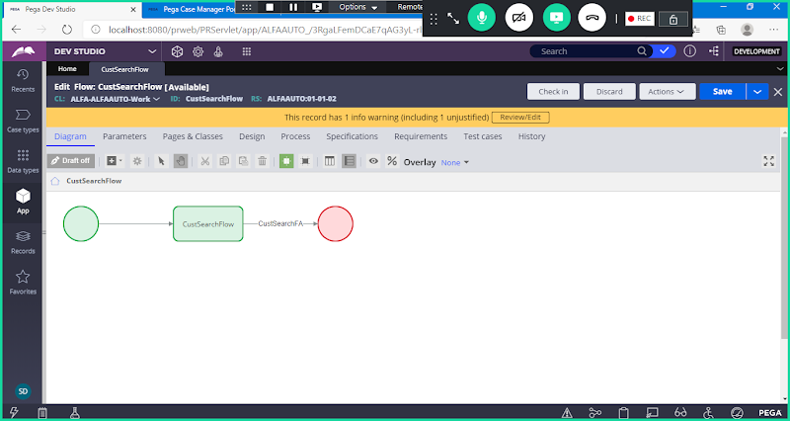

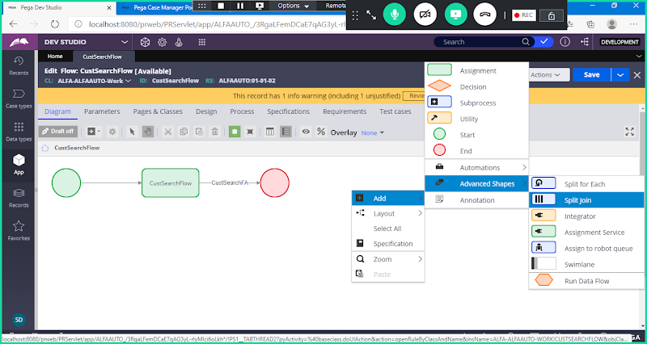

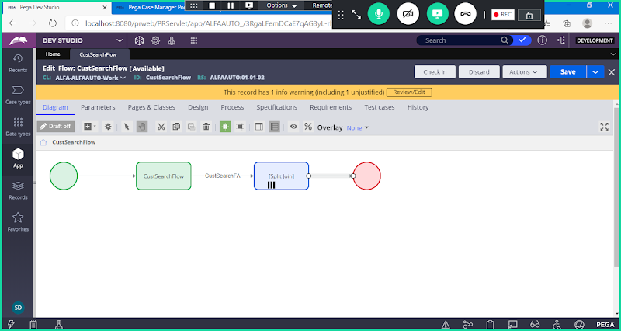

**Open Split Join Shape**

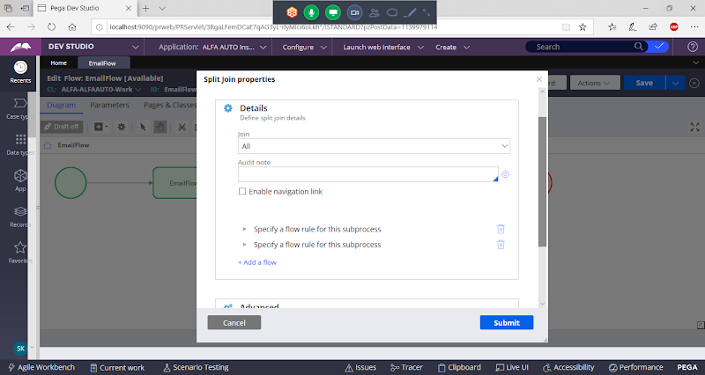

**Now Add One or More flows**

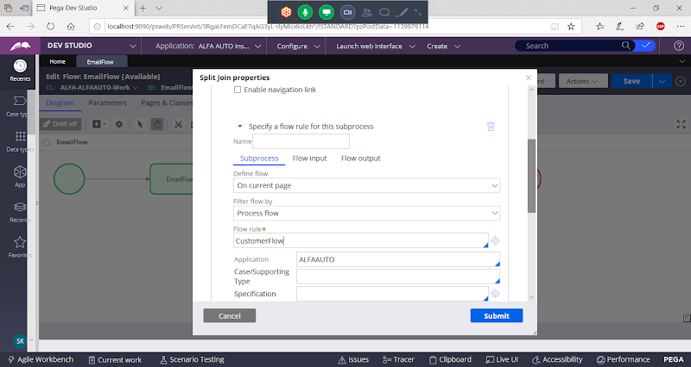

**Add Another in Another Subprocess**

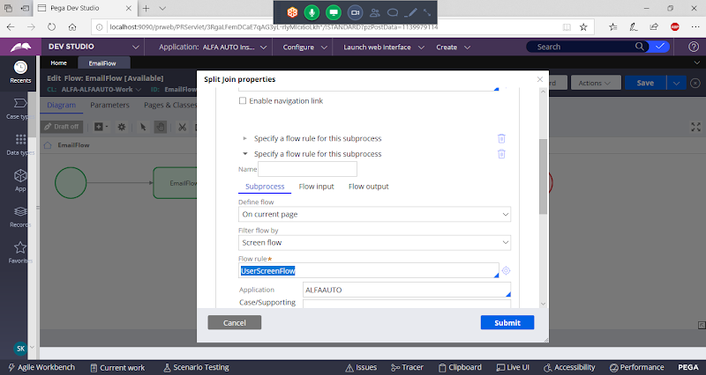

**Submit**

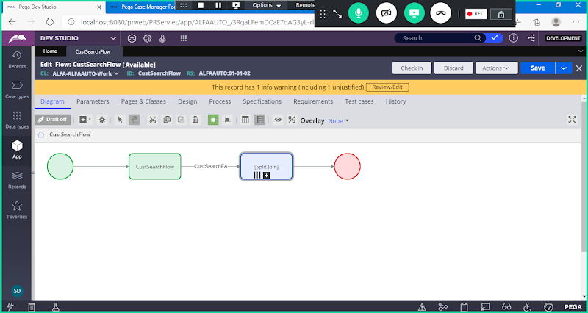

**Now Run the Run**

**=====================**

**Split for each:**

**Working with Split for each:**

**This Flow shape used to call a subflow and we can pass a pagelist. This sub flow will be executed multiple times for each page in the pagelist.**

**- The sub flow should be created under pagelist reference class.( Page Property -Section-Flowaction-SubFlow)**

**ReQ: Make changes to Existing manager approval process, such that Approval should be sent to all the managers of our application. If any one of the manager approves, Work item can be processed.**

**Create a Page List Property referring to Operator ID Class: ( Data-Admin-Operator-ID)**

**Create a Page List Property under Work Class group:**

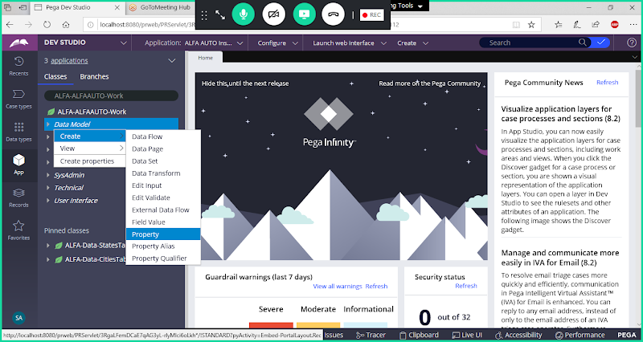

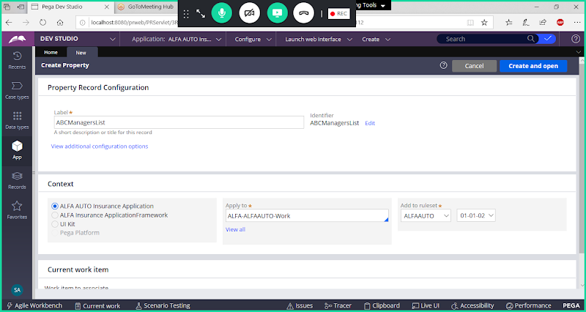

**Select Type: Pagelist**

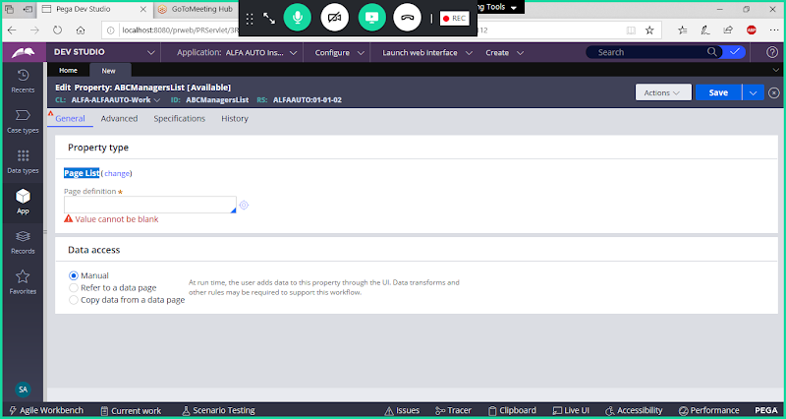

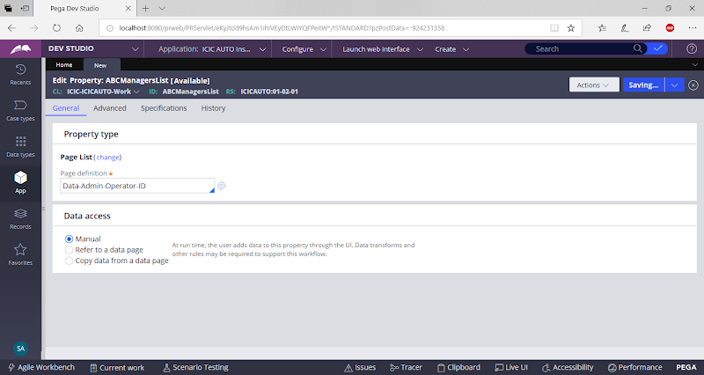

**Save Proeprty**

**Create all the rules under Operator ID Reference Class ( Data-Admin-Operator-ID)**

**Open Data-Admin-Operator-ID Class:**

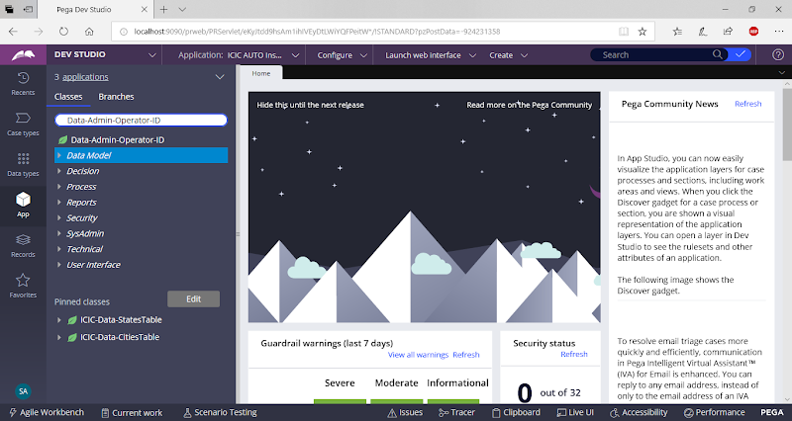

**Create Page Property referring to Approval Data Class:**

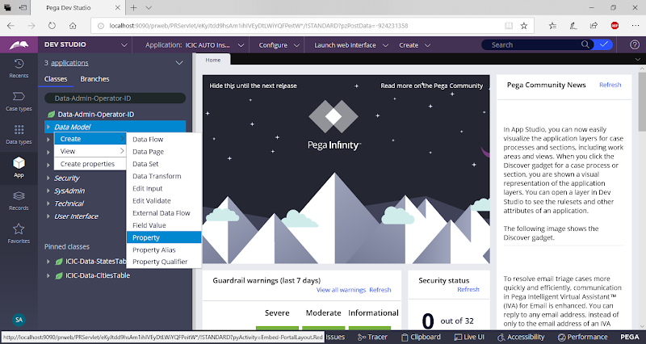

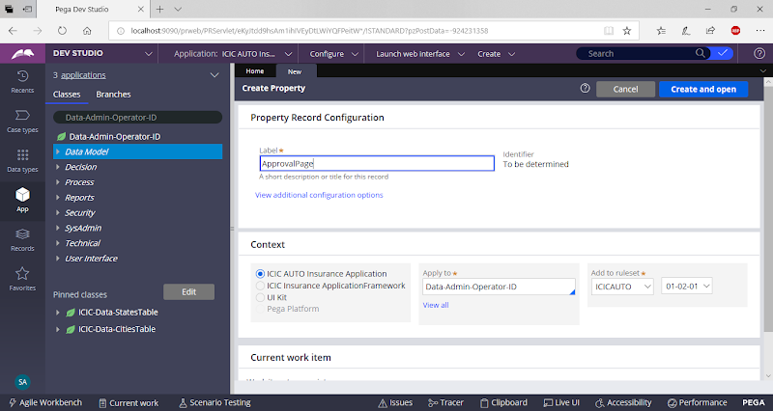

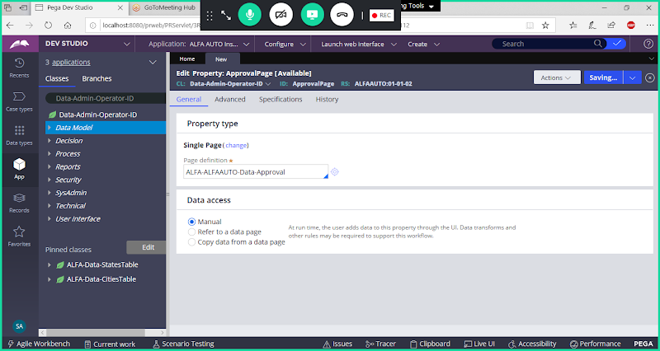

**Save Property**

**Create a section under Data-Admin-Operator-ID Class:**

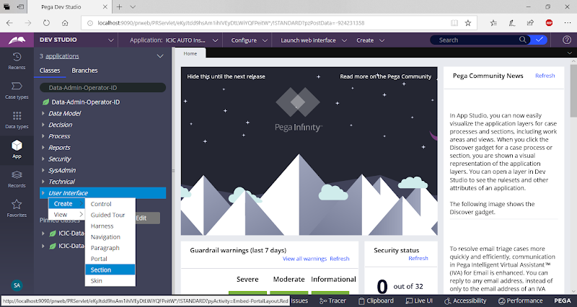

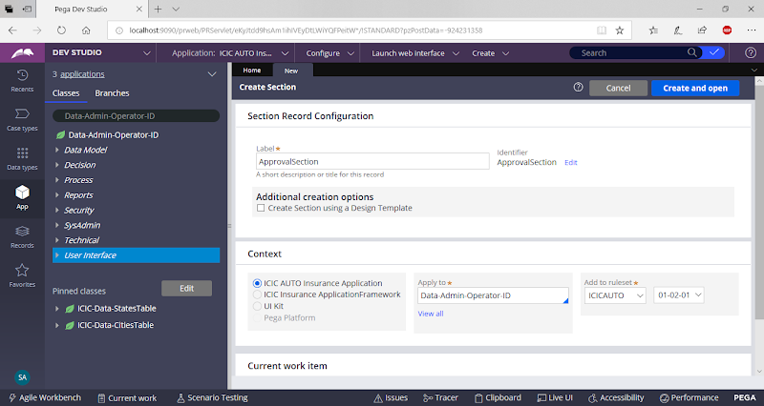

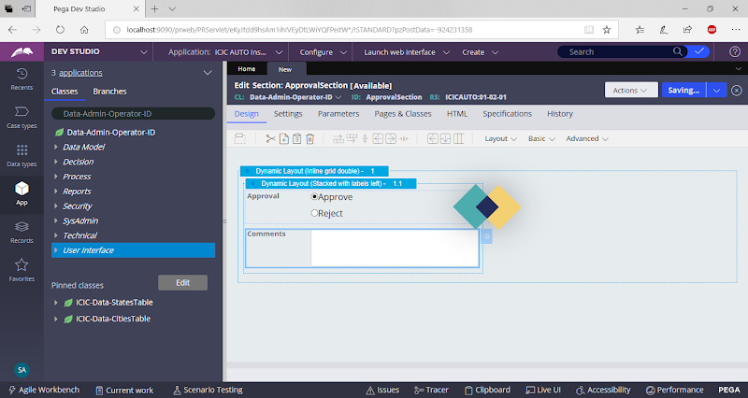

**Save section**

**Add a Flowaction:**

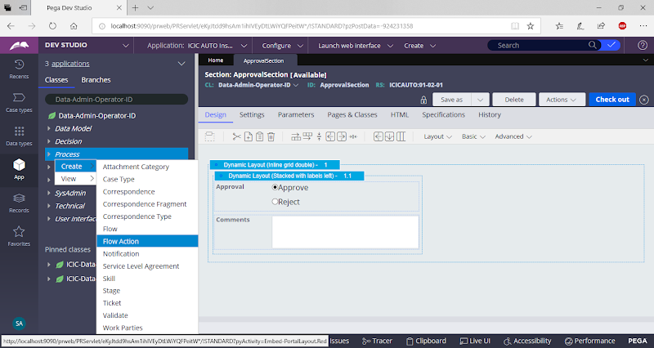

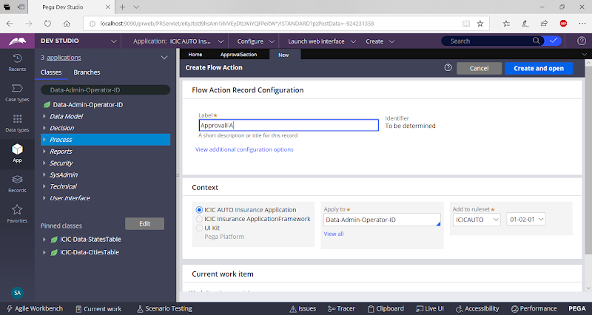

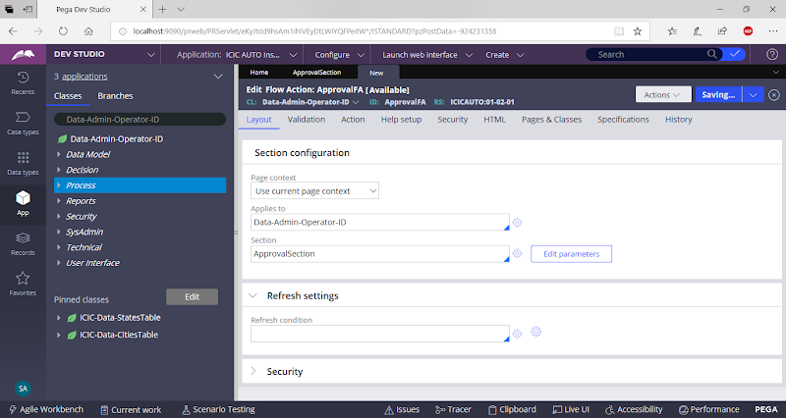

**Save Flowaction**

**Create a Sub flow:**

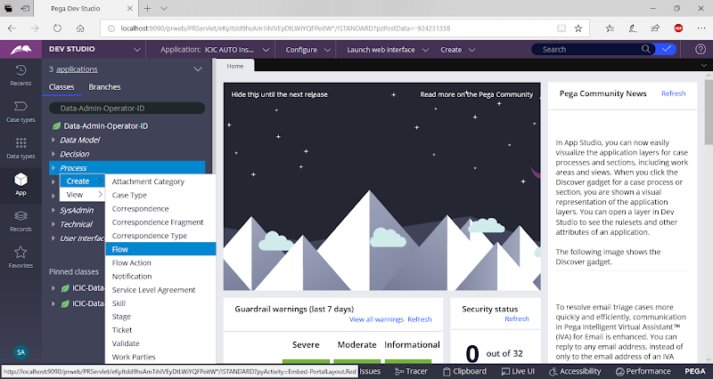

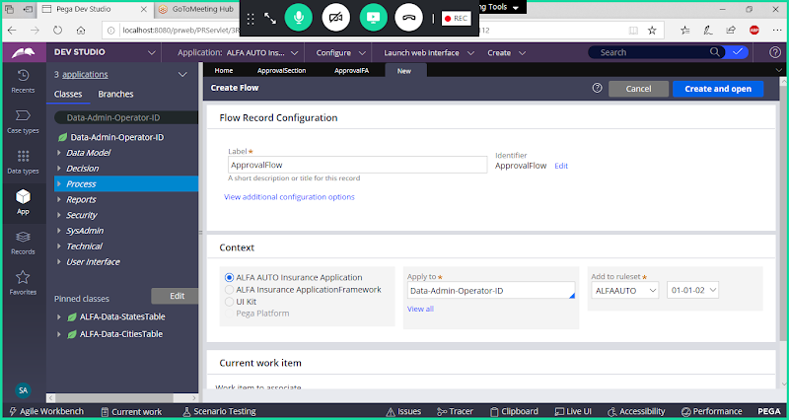

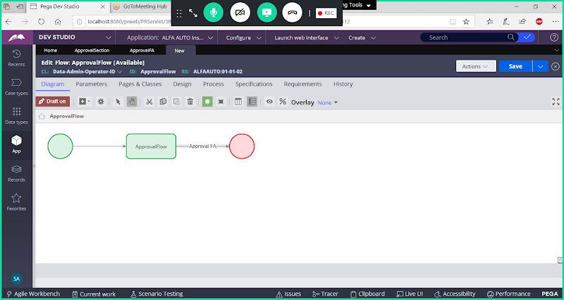

**Add Approval FA & Routing**

**Add Routing:**

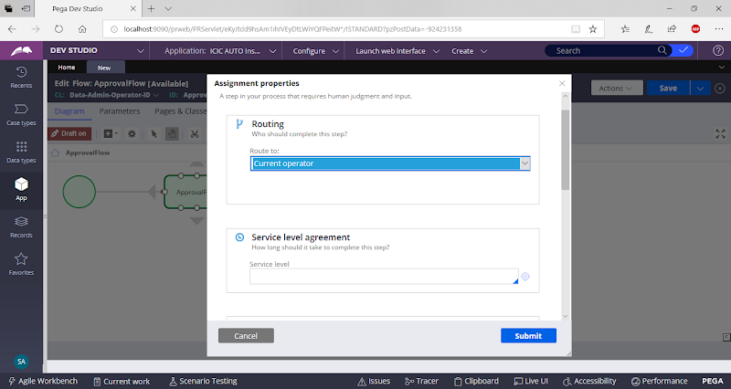

**Select Custom**

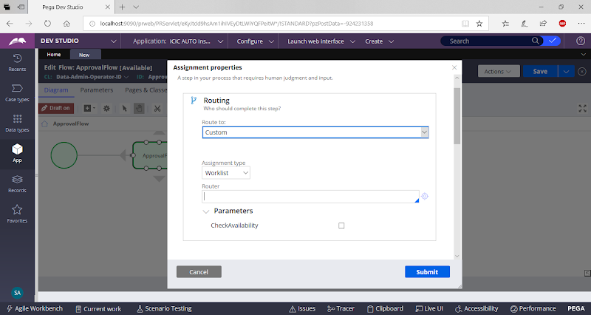

**Under Router Select toWorkList**

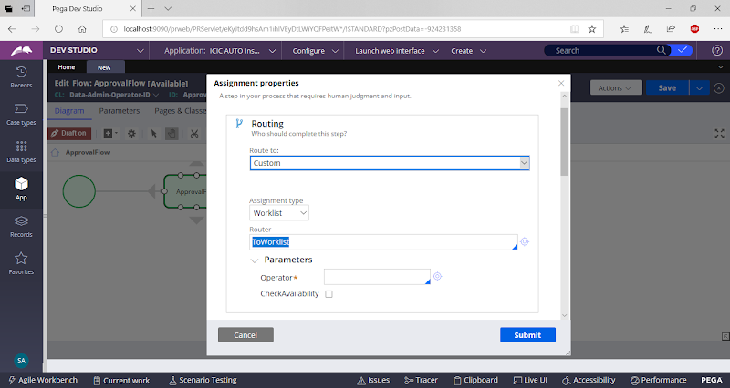

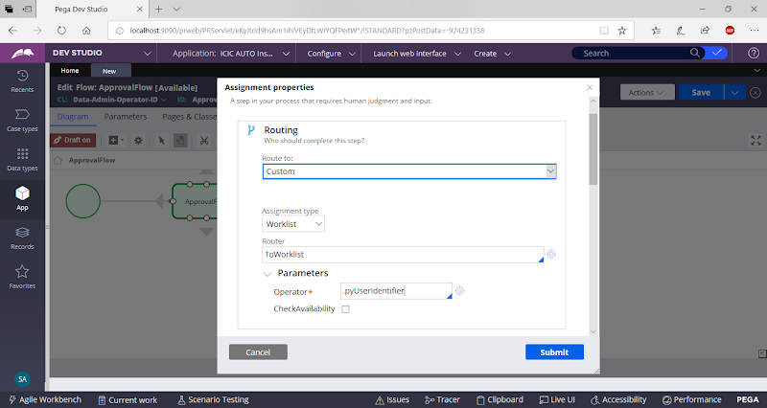

**Submit**

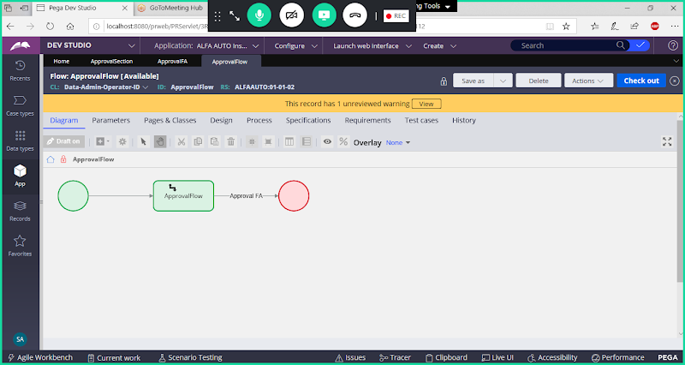

**Save & Check in**

**Create Activity under Work Layer to fetch all the manager id's & copy results to ManagersList**

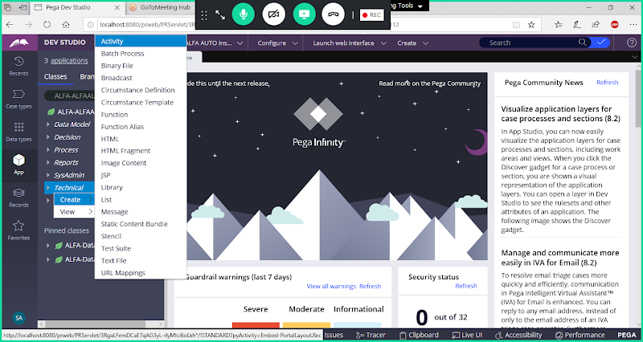

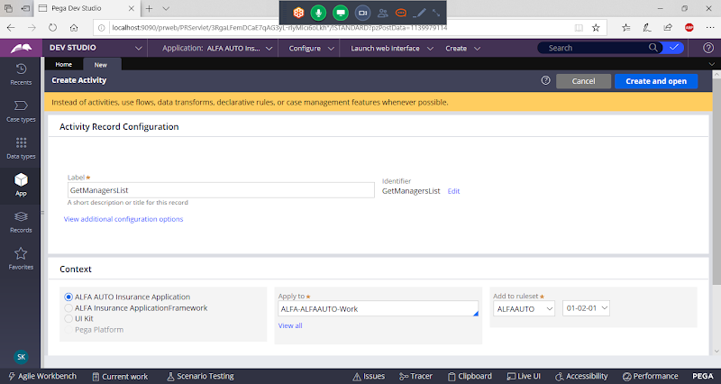

Open

**Go to Pages & Classes**

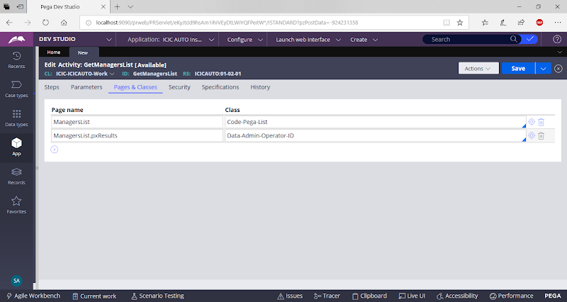

**Go to steps tab:**

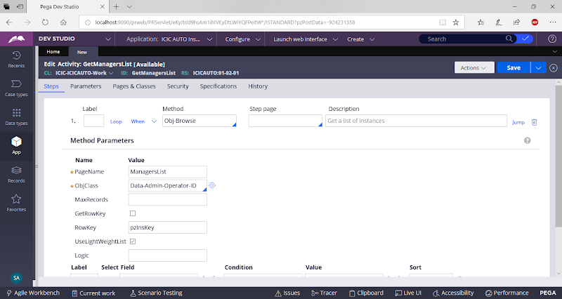

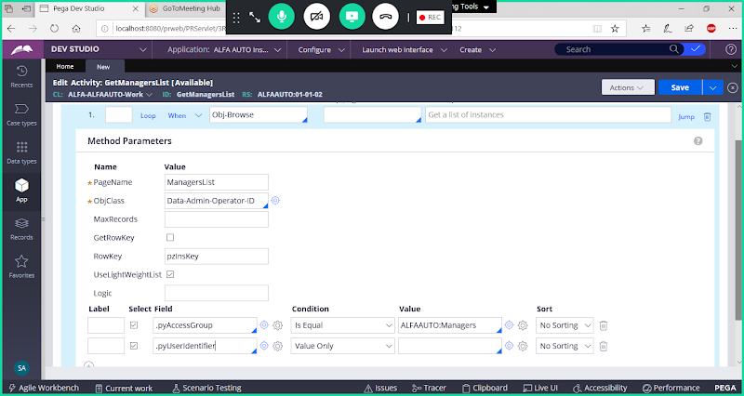

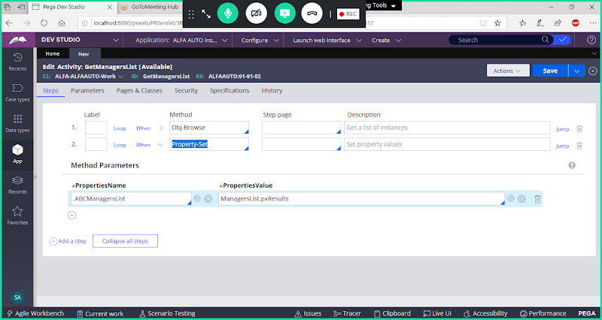

**Save Activity**

**Now Call Activity in LOSS Flowaction Under Post Processing**

**Open LOSS Flowaction:**

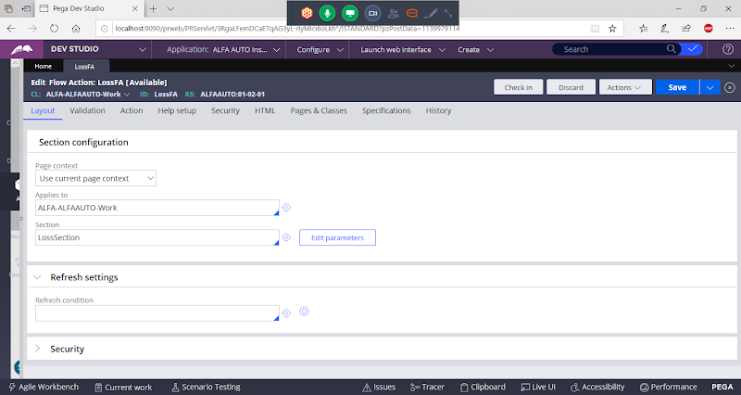

**Call Activity under Post processing**

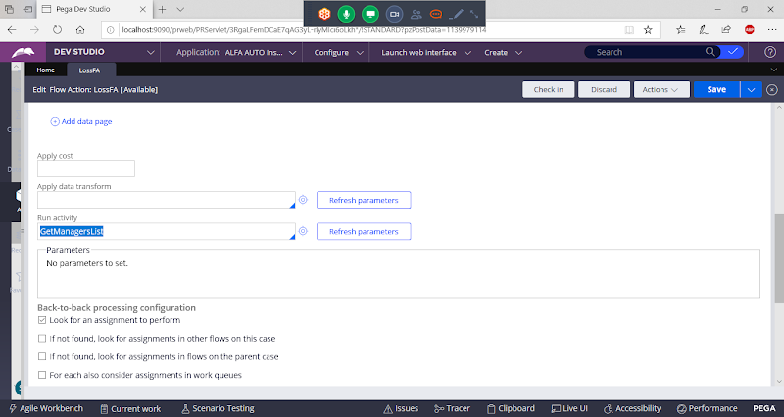

**Save FlowAction**

**Open Insurance Flow**

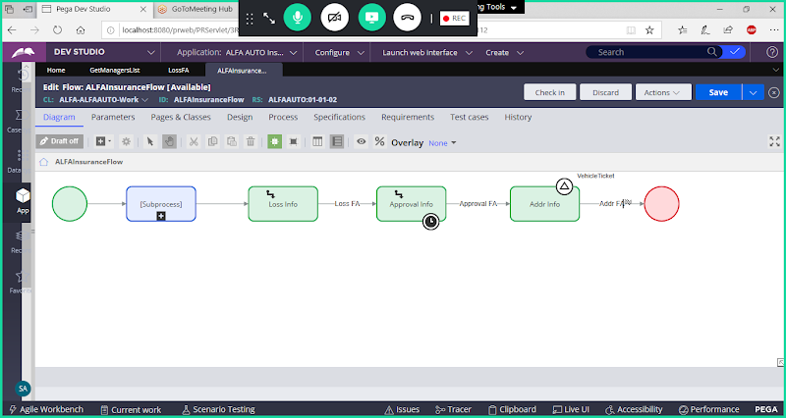

**Delete  Approval Details assignment & Connector**

**Add Split for each shape After Loss Details.**

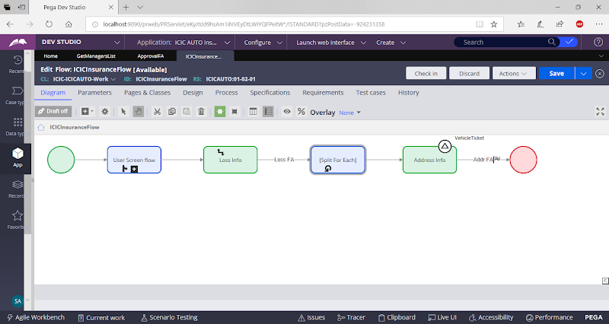

**Now configure split for each & Call Sub flow:**

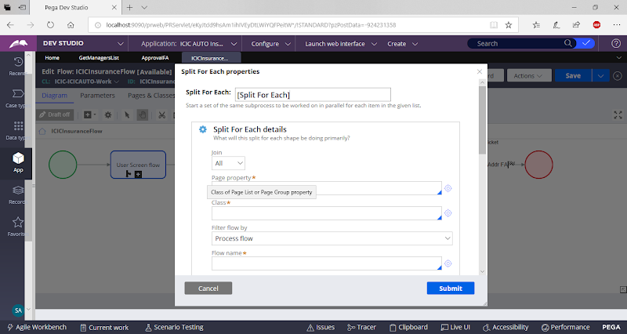

**Select Join Condition as Any**

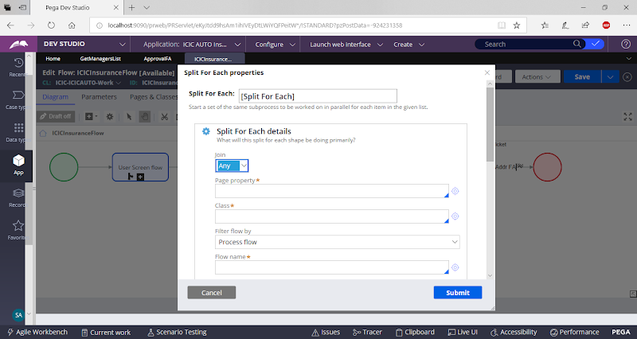

**Add Required Paraemters**

**Add Pagelist Property & Reference Class**

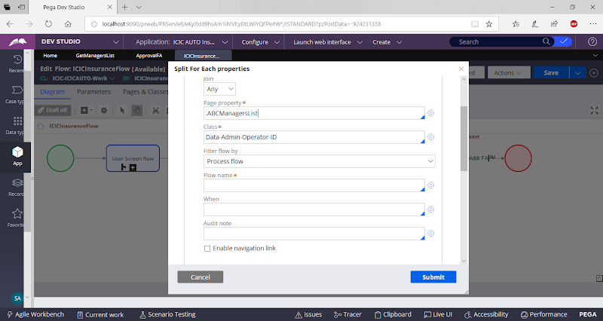

**Add Sub Flow Name:**

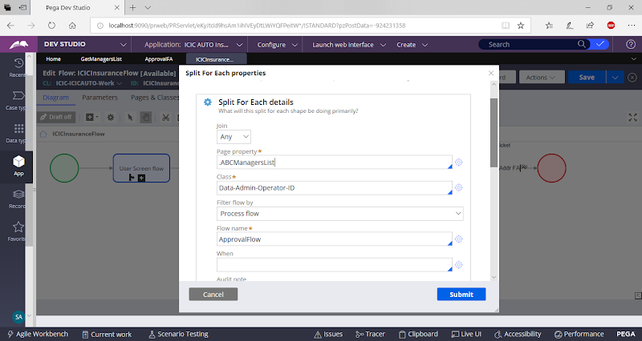

Submit

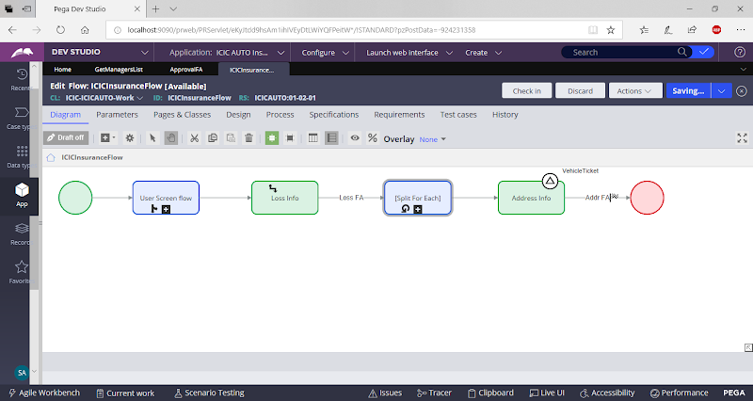

**Save Flow & Check in**

**When you execute the Flow & Submit Loss Details**

**Only Submit Loss FA**

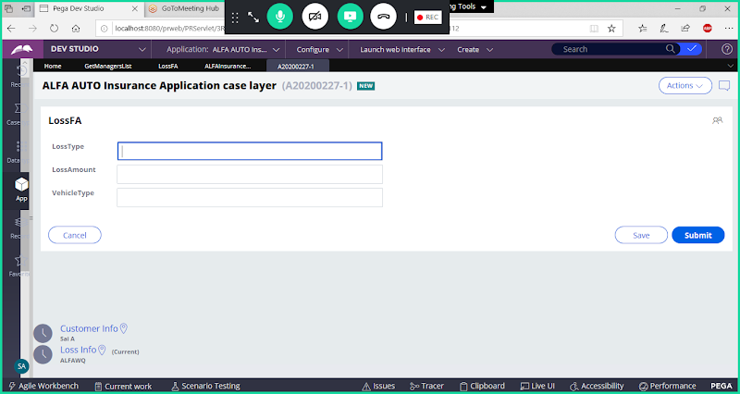

**Submit Loss Form.**

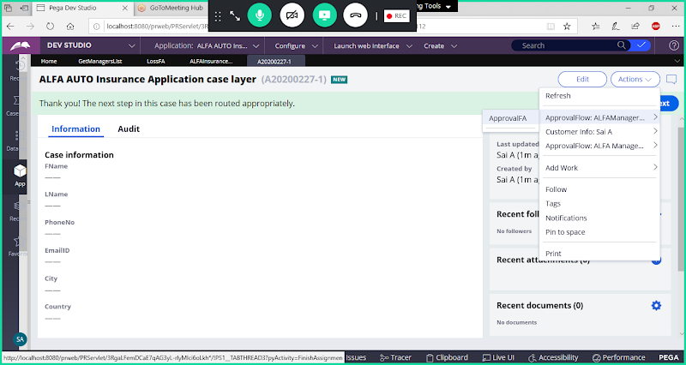

**Now you can see all manager id's, submit the work item from any one manager id. Work item will be processed & completed.**

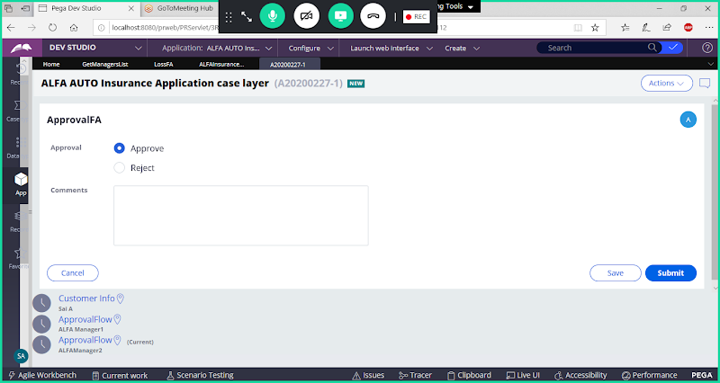

**Submit**

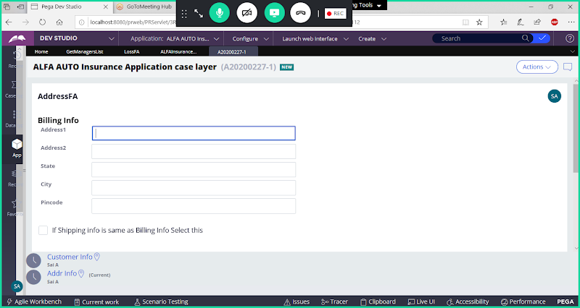

**Approve the Work Item From One Manager ID**

**Click 0n Submit**

**Now if we check with other Manager Id's there is no work item to process.**

**Now Any one Manager can approve Then work item will be moved to next step.**